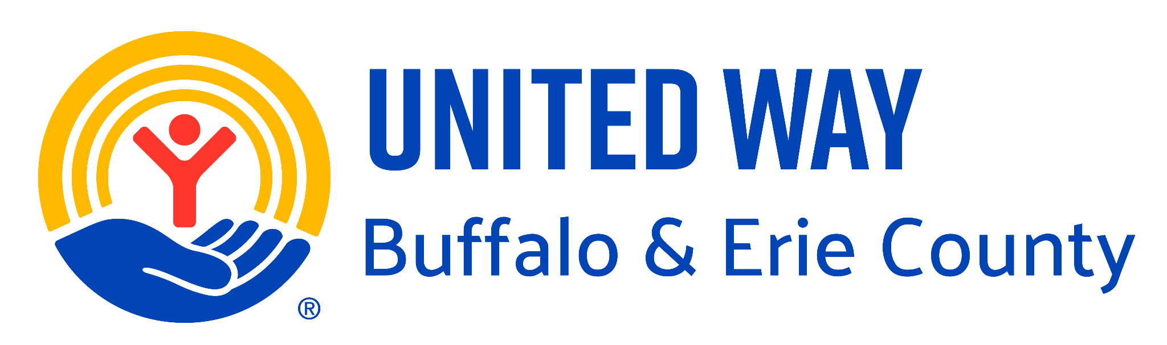 2026 Pitch10 RFP Questions

United Way of Buffalo & Erie County
2026 Pitch10 Request for Proposal
Frequently Asked Questions

Below are the answers to frequently asked questions about the Pitch10 RFP process. Please send any questions you may have to Pitch10@uwbec.org by Friday, July 17, 2026. We will update this document throughout the application period as new questions come in, with the most recent questions posted at the top. The final updated document will be posted on July 24, 2026.

If I submit an RFP response and am chosen as a finalist to pitch on October 22, 2026, is it mandatory that I attend the Pitch10 workshop and dress rehearsal?

Yes. Each organization chosen as a finalist must attend the Pitch10 workshop and dress rehearsal as part of the requirements of the overall process.

If I was previously awarded funding or pitched through the Pitch10 RFP process, can I submit another RFP response to be considered again?

You are not eligible to respond to the 2026 RFP if you pitched in 2025 or ever won the first, second or third place prize.

If I submitted an RFP response in the past but was not chosen as a finalist, can I submit another RFP response?

Yes, if you were not chosen as a finalist in the past, you may submit another response for consideration.

Community Resiliency is one of the UWBEC platform areas. Can I submit an RFP response for work that aligns with Community Resiliency?

No. While community resiliency is one of United Way’s four focus areas, we are not funding programs in the Community Resiliency focus area through this RFP. For this RFP, your program must align with one of the following focus areas: Youth Opportunity, Financial Security, or Healthy Community.

